Executive Summary |  | 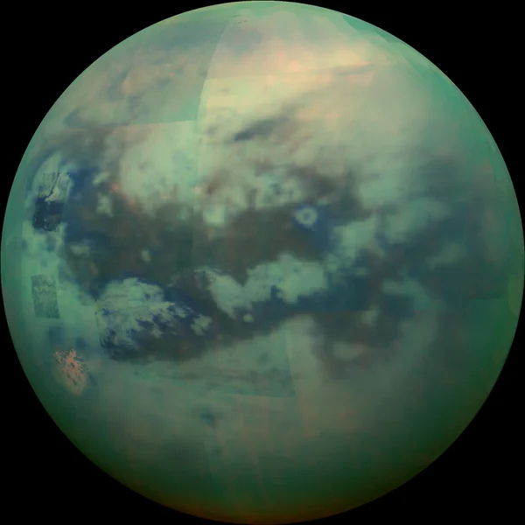
Per-Imhotep is a space settlement designed to support 180,000 inhabitants in orbit around Saturn's moon Titan. The settlement features a central cylindrical spine (300 m radius, 2,200 m height) supporting three toroidal habitation rings (major radius 1,825 m, minor radius 1,625 m, elliptical cross-section with 200 m semi-major and 100 m semi-minor axes) rotating at 0.7 RPM to generate approximately 1g of centrifugal gravity.
Torus T1 and T3 serve as primary habitation zones encompassing residential areas, entertainment, transportation networks, and daily amenities. Torus T2 is dedicated to agriculture and industrial operations. The central spine houses nuclear energy production facilities, while transport side panels (1,900 m tall, 100 m wide) provide inter-torus connectivity for both human and robotic transit.
The settlement's location near Titan offers strategic advantages: access to methane and nitrogen resources from Titan's atmosphere, water ice from Saturn's rings, and proximity to a rich system of moons for mining operations. Per-Imhotep represents a self-sustaining ecosystem engineered to support long-term human life in the outer solar system.

Construction Phases
Phase 1: Core Spine Assembly: The central cylindrical spine is constructed first, establishing the structural backbone of the settlement. This 2,200 m tall, 300 m radius cylinder houses the nuclear reactors and provides the central axis around which all other components are organized. The spine's structural framework includes mounting points for all subsequent attachments.  Phase 2: Transport Connectors: The side panel transport connectors are installed, extending outward from the spine. These 1,900 m tall, 100 m wide panels will serve as the primary transit corridors between tori, accommodating both human pathways and robotic logistics lanes. Conveyor systems with operational speeds of 2.5-2.8 m/s are integrated during this phase. | 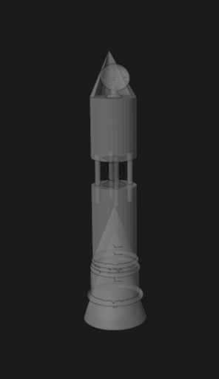 | 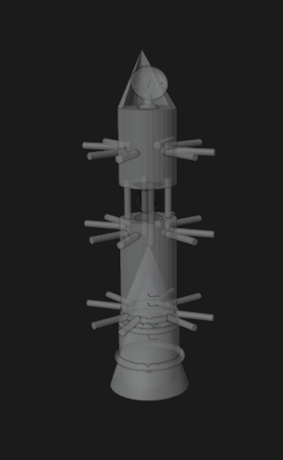
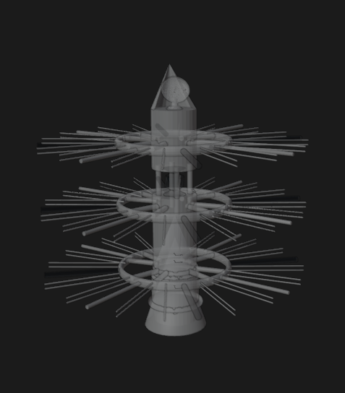 | Phase 3: Structural Integrity Torii: Smaller structural torii are assembled and attached to the spine framework. These rings serve as the skeletal foundation that will bear the loads of the main habitation tori. They establish the rotational geometry and provide the mounting infrastructure for the full-scale rings.  Phase 4: Structural Integrity and Transport Connectors Integration: The structural torii are connected to the transport panels, creating a unified rigid framework. This integration phase ensures that centrifugal forces from torus rotation are properly distributed through the entire structure. Stress testing and alignment verification occur before proceeding.
Phase 5 — Main Torii Installation: The three primary toroidal habitation rings (T1, T2, T3) are constructed and mounted at 400 m intervals along the spine. Each torus features an elliptical cross-section (200 m × 100 m) and is engineered to rotate at 0.7 RPM. Interior buildout begins: T1 and T3 receive residential and civic infrastructure, while T2 is fitted for agricultural and industrial use. | 